Guidelines

Document Requirements for request of Hiring of Laborers | - Request Letter for Job Order (JO) laborers addressed to the Dean  - Workplan and Timetable for Laborers prepared by the Scholar (Requestor) and Endorsed by the Thesis Adviser  - Duties and Responsibilities prepared by the Scholar and Endorsed by the Thesis Adviser  Note:  - 2 laborers with TIN for MS (P14,000.00)  - 4 laborers with TIN for PhD (P28,000.00)
Document Requirements for Request of Payment of Laborers | - Original signed Daily Time Record (DTR) (2 copies per Laborer) with countersign by the Thesis Adviser, approved by Dean  - Accomplishment Report prepared and signed by Laborers, checked by Scholar, Certified by Thesis Adviser, Approved by Dean

Sample Workplan and Duties and Responsibilities

WORKPLAN AND TIMETABLE
- Program Title :
- Thesis/Research Title :
- Total Duration : 30 DAYS
- Planned Start date :
- Planned End date :
- Activities (shown in Table 1)

Table 1. Task or actions to be carried out while conducting the study
TARGET ACTIVITIES | (Month)
TARGET ACTIVITIES | Week 1 | Week 2 | Week 3 | Week 4
(Activities to be conducted)
(Activities to be conducted)
(Activities to be conducted)
(Activities to be conducted)
(Activities to be conducted)

Prepared by:

Name & Signature
Scholar

Endorsed by:

Name & Signature
Thesis Adviser

DUTIES AND RESPONSIBILITIES
LABORER

NAME | TIN | DUTIES/RESPONSIBILITIES | DURATION
 |  | (list down all duties and responsibilities per Laborer) | (Date covered)
 |  | (list down all duties and responsibilities per Laborer) | (Date covered)
 |  | (list down all duties and responsibilities per Laborer) | (Date covered)
 |  | (list down all duties and responsibilities per Laborer) | (Date covered)

Prepared by:

Name & Signature
Scholar

Endorsed by:

Name & Signature
Thesis Adviser

SAMPLE DTR and Accomplishment Report
(Submitted after the requested Duration of Laborers)
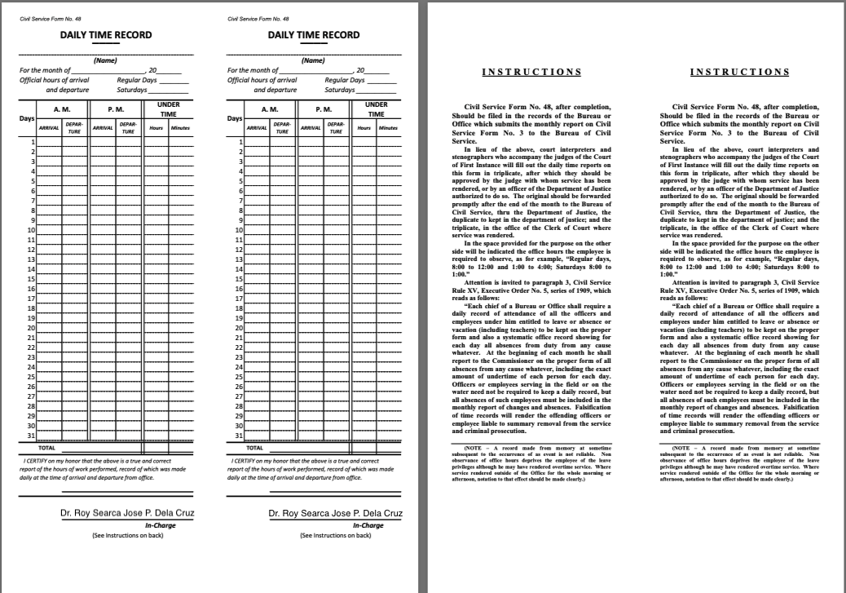

ACCOMPLISHMENT REPORT
Project/Thesis/Research Title :
Date | Activities | Accomplishment
Week 1 (Date Covered) | (list of activities) | 100 %
Week 1 (Date Covered) |  | 100%
Week 1 (Date Covered) |  | 100%
Week 1 (Date Covered) |  | 100%
Week 2 (Date Covered) | (list of activities) | 100 %
Week 2 (Date Covered) |  | 100%
Week 2 (Date Covered) |  | 100%
Week 2 (Date Covered) |  | 100%
Week 3 (Date Covered) | (list of activities) | 100 %
Week 3 (Date Covered) |  | 100%
Week 3 (Date Covered) |  | 100%
Week 3 (Date Covered) |  | 100%
Week 4 (Date Covered) | (list of activities) | 100 %
Week 4 (Date Covered) |  | 100%
Week 4 (Date Covered) |  | 100%
Week 4 (Date Covered) |  | 100%
Prepared by:

Name & Signature
Laborer

Checked by:

Name & Signature
Scholar

Certified by:

Name & Signature
Thesis Adviser

Approved by:

Dr. Roy Searca Jose P. Dela Cruz
ERDT Project Leader & Acting Dean, College of Engineering

